# STREETFOODS REQUIREMENTS SPECIFICATION

# I. FRONT END (for End Users)

## 1. Unlogged_Homepage:

* Header: Logo, Statement “Chao Mung Den Voi StreetFoods.vn”, “Dang Nhap” link, “Dang Ky” link, top banners, 3 icons (Facebook, Google+, Yahoo).

+ Click on “Dang Nhap” link, the Login popup should display.

+ Click on “Dang Ky” link, the Signup popup should display.

+ Click on banner, user is redirected to website of banner respectively.

+ Click on Social icons, new tap will be launched for social networks respectively.

* Left/ Right bar: banners
* Tap Menu: Trang Chu
* MAP DEFAULT
* Search text box: Input Name of Course
* “Tim Kiem” button: Click on this button, user is redirected to Seach Result page if the key word in Search text box matches any item in Database
* “Nhap ten quan” text box: User can input Name of Store here
* “Thanh Pho” dropdown list: Contains Names of Cities
* “Quan” dropdown list: Contains Names of Districts of respective City
* “Thoi gian hoat dong” dropdown list: Contains “Sang”, “Trua”, “Chieu”, “Toi”, ‘Ca Ngay”
* User can search even only one field is inputted correctly
* Hot News field: Information of any Hot News/ Promotions/ Discounts/…
* Footer: “Trang chu” link, “Gioi thieu” link, “Lien he quang cao” link, “Y kien phan hoi” link

+ Click on “Trang chu” link, user is redirected to “Unlogged_Homepage”

+ Click on “Gioi thieu” link, user is redirected to “Gioi thieu” page

+ Click on “Lien he quang cao” link, user is redirected to “Lien he quang cao” page

+ Click on “Y kien phan hoi” link, user is redirected to “Y kien phan hoi” page

* Copyright of Website
* Thong Tin Dia Chi Website: Address/ Email/ Phone for contact purpose of Website.

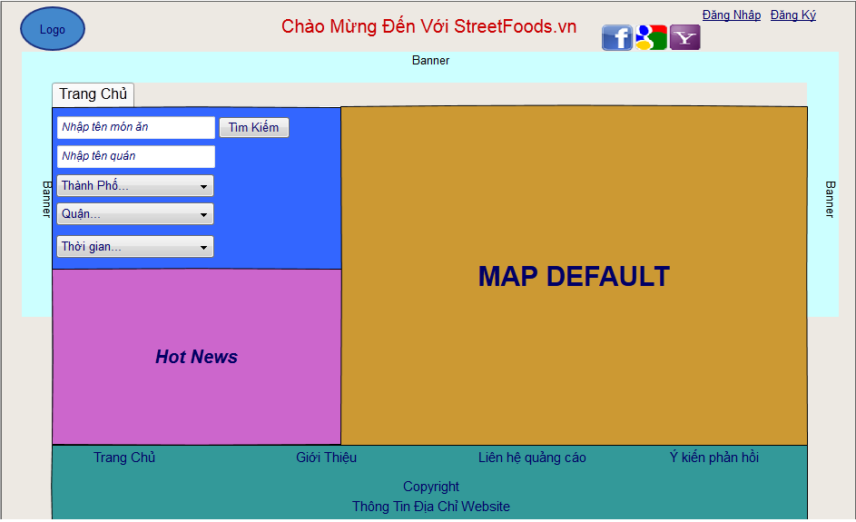

Note: Information of “Gioi Thieu”, “Lien he quang cao”, “Y Kien Phan Hoi”, “Copyright”, “Thong Tin Dia Chi Website” will be provided later.

### 1.1 Login Popup: (after clicking on “Dang Nhap” button at header of website)

* There are 4 buttons (3: Facebook/ Gmail/ YahooMail and 1: Login)
* By default, User can login the website by website User
* User can access website by 3 account types above by clicking on the button respectively
* UserName text box: Input UserName of each account type
* Password text box: Input PW of UserName
* “Nho mat khau” chẹck box
* “Quen mat khau” link
* Click on “Dang Nhap” button after:

+ Inputting correct values for fields, user is redirected to Logged_Homepage_1

+ Inputting any incorrect value for fields, Error message will appear

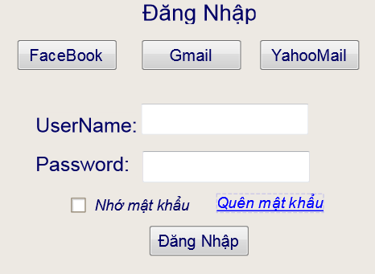

### 1.2 Signup Popup: (after clicking on “Dang Ky” button at header of website)

* There is 1 button (Signup)
* UserName text box: Input new UserName
* Password text box: Input PW of new UserName
* Password text box: Re-nput PW of new UserName
* Email text box: Used to confirm Signup process
* Click on “Dang Ky” button after:

+ Inputting correct values for fields, A Successful message should be displayed. User will activate the new UserName from his Inbox Email.

+ Inputting any incorrect value for fields, Error message will appear

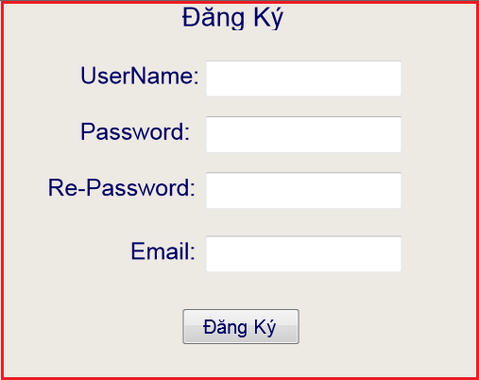

## Logged_Homepage_1: (Access the website after Login successfully)

* Header: Logo, Statement “Chao Mung Den Voi StreetFoods.vn”, “UserName” link, “Thoat” link, top banners, 3 icons (Facebook, Google, Yahoo).
* Left/ Right bar: banners
* Tap Menu: Trang Chu (Highlighted as default), Nhung noi yeu thich, Nhung noi da xem, Tai khoan, De cu
* MAP DEFAULT
* Search text box: Input information
* “Tim Kiem” button: Click on this button, user is redirected to Seach Result page if Key word in Search text box maps any item in Database
* “Nhan ten quan” text box: User can input Name of Store here
* “Thanh Pho” dropdown list: Contains Names of Cities
* “Quan” dropdown list: Contains Names of Districts of respective City
* “Thoi gian hoat dong” dropdown list: Contains “Sang”, “Trua”, “Chieu”, “Toi”, ‘Ca Ngay”
* User can search even only one field is inputted correctly
* Hot News field: Information of any Hot News/ Promotions/ Discounts/…
* Footer: “Trang chu” link, “Gioi thieu” link, “Lien he quang cao” link, “Y kien phan hoi” link

+ Click on “Trang chu” link, user is redirected to “Logged_Homepage_1”

+ Click on “Gioi thieu” link, user is redirected to “Gioi thieu” page

+ Click on “Lien he quang cao” link, user is redirected to “Lien he quang cao” page

+ Click on “Y kien phan hoi” link, user is redirected to “Y kien phan hoi” page

* Copyright of Website
* Thong Tin Dia Chi Website: Address/ Email/ Phone for contact purpose of Website.

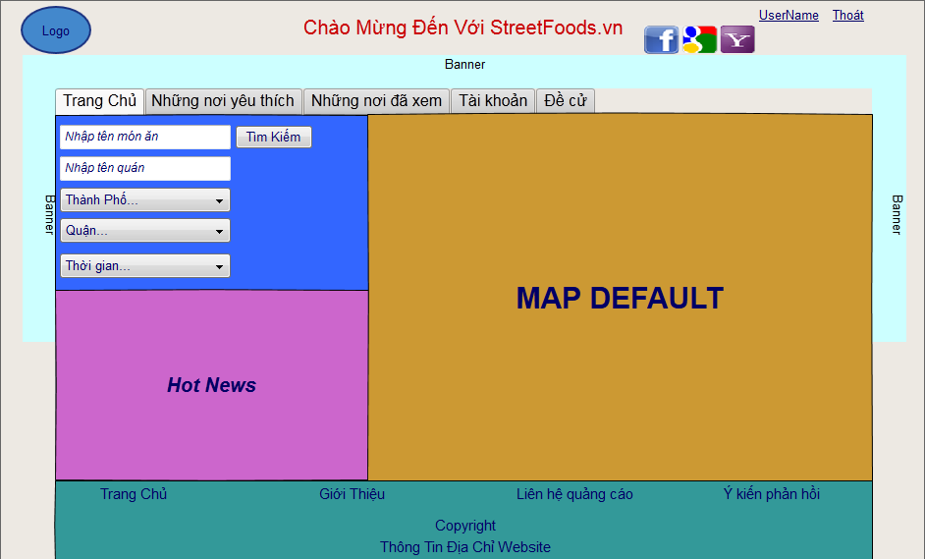

Note: Information of “Gioi Thieu”, “Lien he quang cao”, “Y Kien Phan Hoi”, “Copyright”, “Thong Tin Dia Chi Website” will be provided later.

### 2.1 Logged_Homepage_2: (After clicking on “Nhung noi yeu thich” tab)

* Header: Nhung noi yeu thich (Highlighted)
* Top/ Left/ Right Bar: No change
* Footer: No Change
* MAP: Map with position of the first Store in the list in left side
* List of favorite Stores in left side:

+ Names of Stores, Addresses of Stores, Short description of Store

+ Scores of Stores: 1-10

+ Status of Stores: “Xac Nhan”, “Chua Xac Nhan”

+ The order of list is descending of Score. If the same Score, the order is descending of the Number Likes of Store.

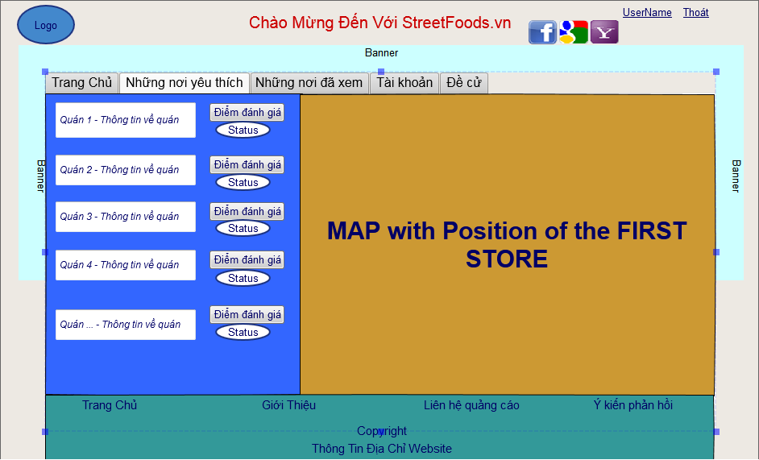

### 2.2 Logged_Homepage_3: (After clicking on “Nhung noi da xem” tab)

* Header: Nhung noi da xem (Highlighted)
* Top/ Left/ Right Bar: No change
* Footer: No Change
* MAP: Map with position of the first Store in the list in left side
* List of Stores User viewed in left side:

+ Names of Stores, Addresses of Stores, Short description of Store

+ Scores of Stores: 1-10

+ Status of Stores: “Xac Nhan”, “Chua Xac Nhan”

+ The order of list is descending of Score. If the same Score, the order is descending of the Number Likes of Store.

+ Time of Viewed: Date + Time of View

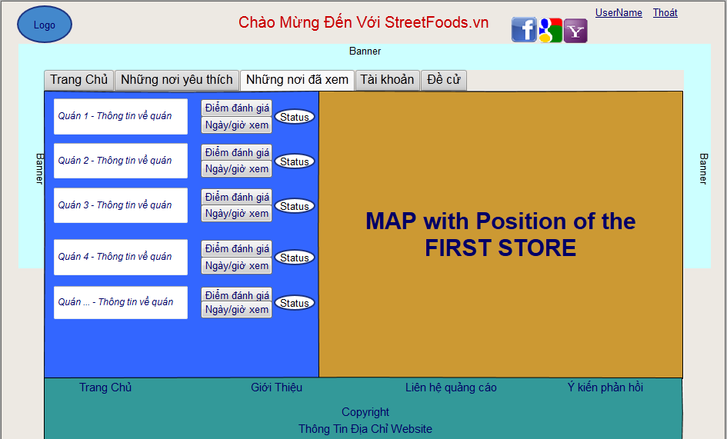

### 2.3 Logged_Homepage_4: (After clicking on “Tai khoan” tab)

* Header: Tai khoan (Highlighted)
* Top/ Left/ Right Bar: No change
* Footer: No Change
* MAP DEFAULT
* Information of User:

+ UserName

+ Change Password

+ Email of User

+ Number of Stores User liked/ disliked/ commented

+ Number of Stores User suggested

* List of Friends: Contains User’s friends on website

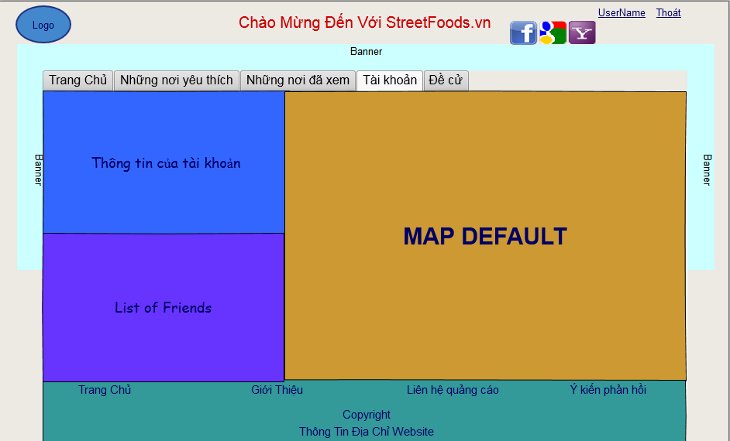

### 2.4 Logged_Homepage_5: (After clicking on “De cu” tab)

* Header: De cu (Highlighted)
* Top/ Left/ Right Bar: No change
* Footer: No Change
* Information of Suggestion:

+ Name of Store text box: User inputs Name of suggested Store

+ Address of Store text box: User inputs Address of suggested Store

+ Courses of Store text box: User inputs Courses of suggested Store

+ “Thoi gian hoat dong” dropdown list: Contains “Sang”, “Trua”, “Chieu”, “Toi”, ‘Ca Ngay”.

+ Description text box: User inputs comments for suggested Store

+ Picture: User can browse to upload 1 picture for the suggestion.

* Information of Validation:

+ Score of Quality of Store dropdown list: 1-10

+ Score of Price of Store dropdown list: 1-10

+ Score of Serving of Store dropdown list: 1-10

+ Total Score: 1-10, calculated by 3 scores above

* Suggestion button:

+ If all fields are inputted properly, User submits the suggestion successfully to Website Email.

+ If one filed is inputted incorrectly, an Error message should be displayed.

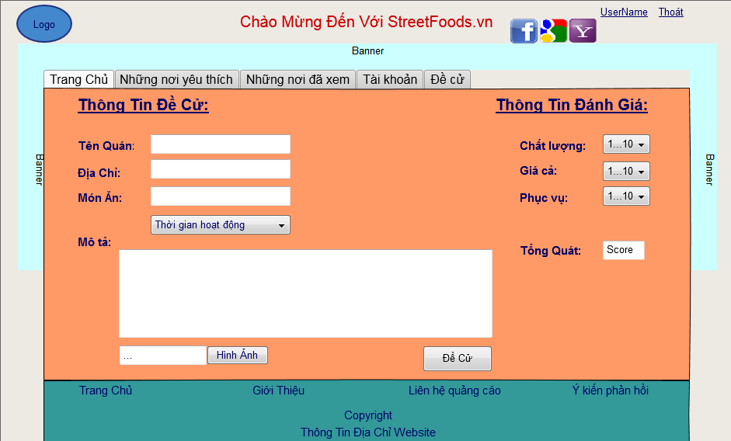

## 3. Search result page:

After inputting necessary information, User clicks on Search button from Homepage. The Search Result page displays as below:

* List of matched Stores displays in left side (Refer to Logged_Homepage_2):

+ Names of Stores, Addresses of Stores, Short description of Store

+ Scores of Stores: 1-10

+ Status of Stores: “Xac Nhan”, “Chua Xac Nhan”

+ The order of list is descending of Score. If the same Score, the order is descending of the Number Likes of Store.

* MAP: Icons and Names of Stores display with correct positions on Map (Size of Map is more than ½ size of page, maybe 60-75%).
* “Tim kiem nang cao” button displays next Search icon. When clicking on this button, the Advance Search field will be displayed.
* User can change information in Search text box.

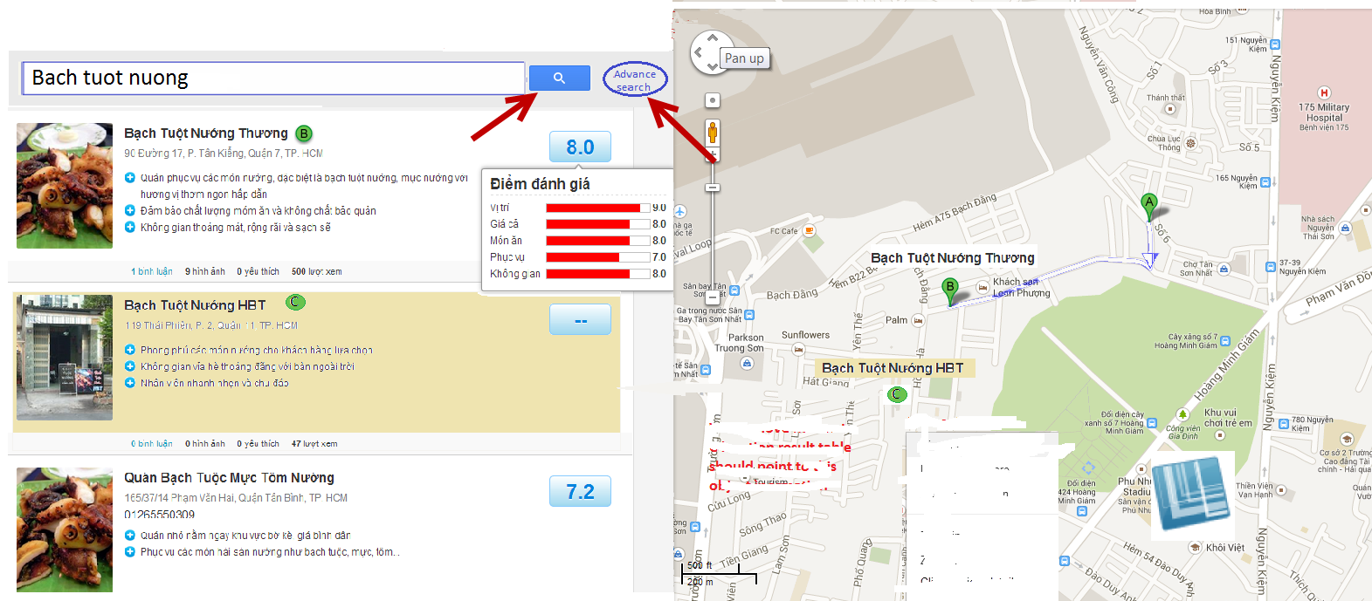

### 3.1 Search field, general information of object

When user is typing some key words in the search field, the search function should automatically list all of object following information:

* General information of Store should show for user aware about product of food (address, name...).
* Score of Store will be appeared when moving mouse on it.
* When clicking on any Store, User is redirected to the Detail Store page.

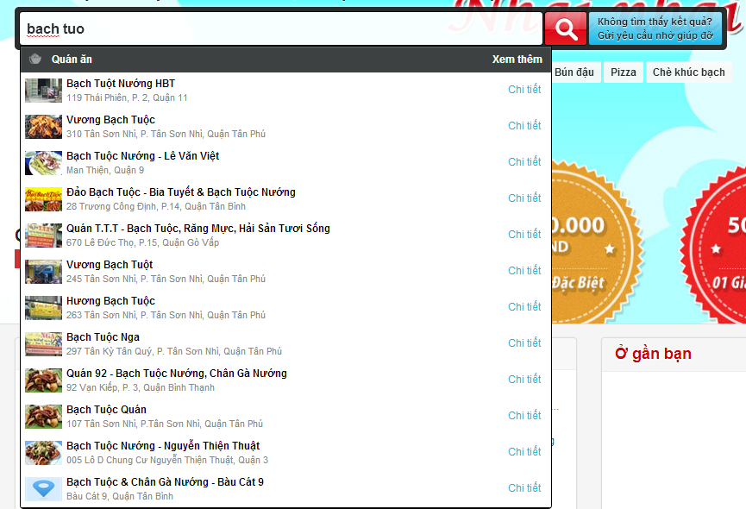

### 3.2 Advance search

If user searched by name of course from Homepage, “Nhap ten mon an” text box will be grey and displayed old name of course has been inputted already. The same behavior for searching by other criteria (Name of Store, District, City, Operating time…).

* After selecting more options in Advance Search and clicking on Search button, user is redirected to Search Result page with list of Stores matching combination of search fields.
* User can go back normal search page by clicking on back button.

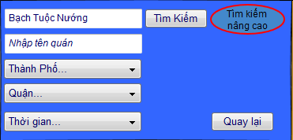

### 3.3 Mapping with object

* When user moves click on position of a Store on map. The correct Store in list (left side) should be highlighted.
* When user click on the Store in list of left side, user is redirected to the detail object page

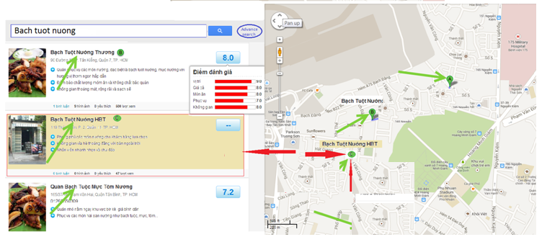

## 3.4 Detail Store page

### Left side is information of Store:

+ Name of Store

+ Address of Store

+ Picture of Store

+ Delicious courses of Store

+ Price range of courses

+ Operation time of Store

+ Score of Store: Automatically calculated by Formula (Number of like*10/ (Number of Like + Number of Dislike)).

+ Like button + Number of Like: only logged users can click on Like button (1 time)

+ Dislike button + Number of Like: only logged users can click on Dislike button (1 time)

+ Share button: When user clicks on Share button, the Store will be shared on facebook wall if user already logged in by FB account. Otherwise, one popup will be appeared to ask user to login to facebook to share this Store.

+ Comment field: If user logged in, he can see some latest comments of Store and he can input comment for the Store. Un-logged users can not input comments, they can see latest comments only.

+ There is place for user to upload the picture of Store. This picture should be sent via email to Admin’s email.

+ Back: User can go back the search result page via this button

### Right side is Map:

+ My place: When user clicks on this button, one popup will ask him to input his address to the text box or user can click on any position on map to fill the text box. Data is saved and changeable.

+ Get direction: After click to this buttons website will direct the user from A(my place) to B(Store place). If user has not inputted his address, the popup of My place should be displayed.

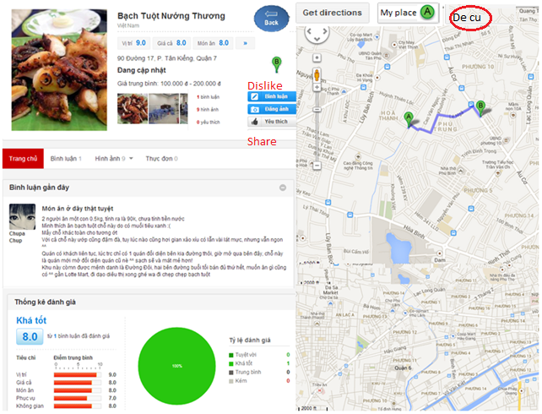

## 3.5 Map requirements

- The map should zoom in zoom out and get direction like Google map.

* The object in map should have name under the object symbol with right mapping.
* After click to find button all objects in the left list have to be showed in the map with correct position, name and number of object.
* MAP: Icons and Names of Stores display with correct positions on Map (Size of Map is more than ½ size of page, maybe 60-75%).

# II. BACK END (for Admin)

## General Management:

* There is interface to manage Admin account, banners, slogan, admin’s email, copyright, address, advertising,…etc.

## Interface to manage end users:

* List of users with the latest actions on web (visited Stores, submitted Suggestion, liked/ disliked/ commented for Stores.
* Ability to lock/ unlock end users.
* Ability to watch which Stores an user visited, liked/ disliked/ commented, suggested.

## Interface to manage Stores:

* List of Stores
* Ability to add/ remove/ delete Stores as well as information of them (Name, Description, Courses, Location, Score, Pictures, Operation time, Number of Like/ Dislike, Comments, Status,…etc).

## Interface to manage Suggestion:

* List of Suggestions
* Ability to watch information of suggestions as well as which users suggested them.